American Society of Regional Anesthesia and Pain Medicine
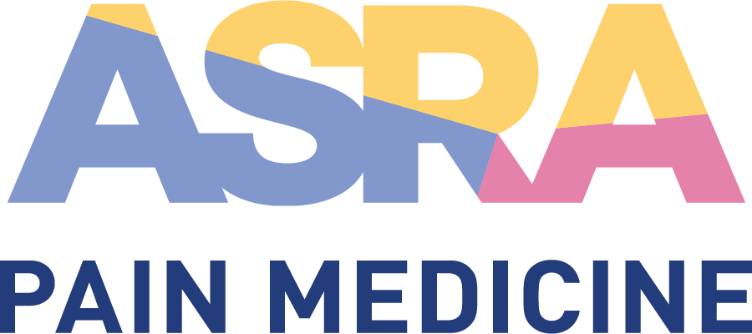
CME Policy

Educational Support Materials

Title | Educational Support Materials
Original Approval | 09/2012
Revisions | 07/9/2022, 08/2018, 07/2017, 05/2014, 02/2014, 12/2012

Purpose
Visual presentations, handouts, and other educational support materials are essential components of quality continuing medical education. Providing such materials in advance of the meeting serves several purposes that are integral to the success of the educational event:
- Help the learner choose between the various educational sessions in order to identify those that best meet their needs
- Enable staff to provide attendees with concrete information about educational sessions
- Facilitate moderators’ coordination of sessions to avoid duplication of content and support objectives
- Allow peer review of content to ensure independence from commercial bias and valid CME content
- Support the learning process before, during, and after the actual conference.

Procedure

Educational Support Materials per Session Type
Educational Support Materials are required for the following (see details below):
- Main Meeting (Refresher Course, Plenary, Parallel, etc.)
- PA/NP/Nursing Programs
- Resident/Fellow Program Lectures (except for workshop sessions)
- PBLDs

Educational Support Materials are not required but strongly encouraged for workshops (see details below). Educational Support Materials are not required for Ask the Expert Interactive Sessions.

Formal Lectures
Presenters giving a formal lecture should submit a PowerPoint presentation. It is the faculty member’s responsibility to follow all copyright and fair use guidelines (see section V. below). All PowerPoint presentations must be submitted in advance for peer review and any conflict of interest mitigation.

PowerPoint Presentation
- Title slide listing lecture title, your name, institution, and location
- Disclosure slide (mandatory even if nothing to disclose; presenters should use the same disclosure slide for all presentations during the meeting)
- Learning objective(s)
- Reference slide

Problem-Based Learning Discussions (PBLDs)
The standardized ASRA Pain Medicine PBLD form is required for all PBLD sessions. The form will be provided electronically only to all attendees online and in the meeting app. Form content includes:
- ~100 word core topic/case study
- Several questions that may be covered in the session
- 4-6 references

Workshops
The emphasis is on maximizing “hands-on” scanning time for the participants. The necessary foundational knowledge for effective workshop participation should be supplied as pre-work educational support material. The exact content is at the discretion of the Program and Workshop Chair, in consultation with workshop leads, but should include some or all of the following:
- Pre-recorded introductory lecture for online viewing
- Curated collection of key references, and readily accessible online learning resources: articles, videos, etc
- 5-6 MCQs for pre-workshop and post-workshop assessment, with an accompanying answer sheet with brief explanations
- A case scenario / study with questions to ponder, along the lines of a PBLD, as a means of setting context for the techniques and skills presented in the workshop

Conflict of Interest Considerations and Mitigation
All educational material should be carefully checked for potential conflict of interest (COI) issues, and must adhere to the following:
- Recommendations involving clinical medicine are based on the best available evidence.
- Scientific research cited conforms to standards accepted by the scientific community.
- No promotional content of a commercial entity (includes product/trade names, photos, logos, company names, etc.). Logos appearing on ultrasound images/machines should not be visible in presentations.
- Use of scientific/generic names; trade names should be used only if necessary, and in those cases the name may be included parenthetically once, but no more. If more than one company makes the product, all applicable trade names should be identified.
- The workshop lead will work to prevent conflict of interest with equipment providers as the representative of ASRA Pain Medicine in the room.

Copyright Guidelines
All copyrighted material adheres to fair use and is appropriately cited.

ASRA Pain Medicine Owned Resources
- Any figure, table, or other content published in the official ASRA Pain Medicine journal, Regional Anesthesia and Pain Medicine (RAPM), and not otherwise owned by an entity other than ASRA Pain Medicine, can be used without copyright permission.
- If ASRA Pain Medicine would like to reproduce content from ASRA Pain Medicine’s official journal (RAPM) and distribute it as an educational support material, formal request for permission is not required. This is true even when seeking to reprint an item in its entirety (e.g., a full article). However, the journal publisher, BMJ, requires that a full acknowledgement be included to document the re-use. Example of acknowledgement format: This article reprinted with permission from Regional Anesthesia & Pain Medicine: November/December 2011, Volume 36, Issue 6, p 592-605. © American Society of Regional Anesthesia and Pain Medicine.
- Similarly, an image from the “ASRA Pain Medicine Image Library” can be used without additional permissions as long as it is being used for educational purposes only.

Patient-Protected Health Information
The faculty member is responsible for ensuring that no patient-protected health information is included in the submitted materials without the patient’s written permission, or that such materials have been thoroughly de-identified. Although not required at submission of materials, the faculty member must be able to produce the written permissions upon request.

Institutional Review Board (IRB) Approval
The faculty member is responsible for ensuring that proper IRB approval has been obtained, as necessary, for any submitted materials. Although not required at submission of materials, the faculty member must be able to produce the written permissions upon request.

Format and Accessibility / Website Accessibility
All submitted educational support materials will be provided to learners in PDF format on the ASRA Pain Medicine meeting website and in the meeting app. Materials will be available in these venues for up to one year after the event. Printed handouts will be used only in limited circumstances when necessary to support the live learning experience. The website with the educational content will include the following wording on the top of the page:

“Educational support materials are available to meeting participants online prior to, during, and after the meeting (up to one year) for educational purposes only. Access to particular content is provided based on meeting registration and is password protected. Distribution is limited and none of the materials should be further distributed or reproduced.”

Resources
- Copyright Basics http://www.copyright.gov/circs/circ01.pdf
- Fair Use Scenarios and Q&A http://poly.libguides.com/content.php?pid=59733&sid=442218
- Regional Anesthesia and Pain Medicine (RAPM) http://www.asra.com/publications-jounal.php

